BIOS 6611

Biostatistical Methods I

Self-assessment Homework #2 - SOLUTIONS

1. Use the information below on low birthweight babies. Answer the questions following. Be sure to show all of your work.

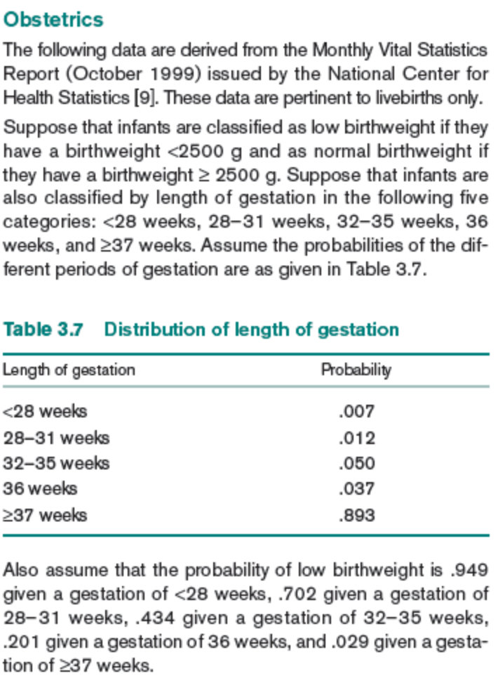

a. What is the probability that length of gestation is ≤ 36 weeks? Is this a joint, marginal or conditional probability?
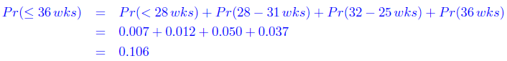
This is a marginal probability.

b. What is the probability that a baby born at > 36 weeks has normal (not low) birthweight? Is this a joint, marginal or conditional probability?
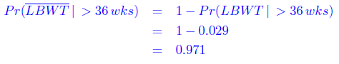
This is a conditional probability.
c. What is the probability of having a low birthweight infant? Is this a joint, marginal or conditional probability?
Total probability rule.
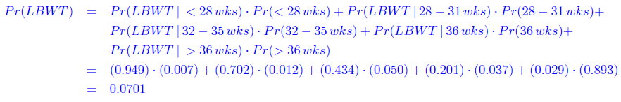
This is a marginal probability.

d. What is the probability of having a baby that arrives earlier than 28 weeks and has low birthweight? Is this a joint, marginal or conditional probability?
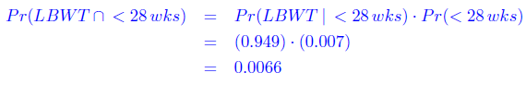
This is a joint probability.

e. Show that the events (length of gestation < 28 weeks) and (low birthweight) are not independent.
Here are 3 approaches to show this:
1) Rosner 8th edition by eqn. 3.5 (p.51):
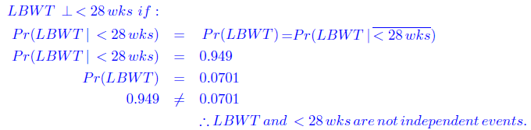
2) Rosner 8th edition by eqn. 3.4 (p.49):
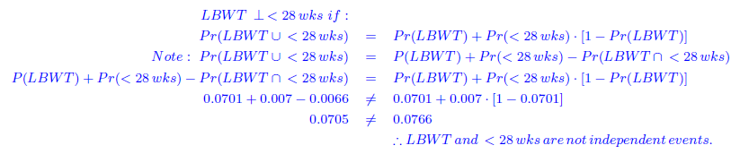
3) Rosner 8th edition by def. 3.7 (p.46):
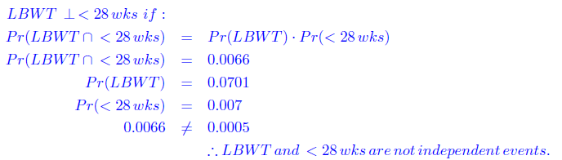

f. If it is known that a child had low birthweight, how likely is it (i.e., what is the probability) that the child was born before 28 weeks?
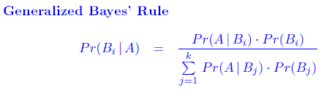
Using equation 3.10 (the generalized Bayes’ Rule), the probability that the child was born <28wks can be calculated.
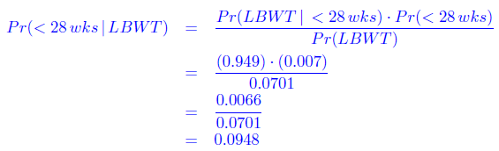
So, given that the child has low birthweight (LBW), then the probability that the child was born before 28 weeks is 9.48%.

g. Construct the conditional probability distribution of gestational age conditional on being low birthweight. Verify that it is a probability distribution. If a child is known to have low birthweight, when was it most probably born?

Conditional probability distribution of gestational age conditional on being low birthweight
Length of gestation | Probability
<28 weeks | 0.0948
28-31 weeks | 0.1202
32-35 weeks | 0.3096
36 weeks | 0.1061
>36 weeks | 0.3694
 | ≈1
Here are the calculations:
Gestation Age Probability
<28 wks .0948 (.007)(.949)/{(.007)(.949) + (.012)(.702) + (.050)(.434) + (.037)(.201) + (.893)(.029)}
28-31wks .1202 (.012)(.702)/{(.007)(.949) + (.012)(.702) + (.050)(.434) + (.037)(.201) + (.893)(.029)}
32-35wks .3096 (.050)(.434)/{(.007)(.949) + (.012)(.702) + (.050)(.434) + (.037)(.201) + (.893)(.029)}
36 wks .1061 (.037)(.201)/{(.007)(.949) + (.012)(.702) + (.050)(.434) + (.037)(.201) + (.893)(.029)}
>=37 wks .3694 (.893)(.029)/{(.007)(.949) + (.012)(.702) + (.050)(.434) + (.037)(.201) + (.893)(.029)}

Given that child is born with low birthweight, it is most probable that the patient was born after 36 weeks or between 32-35 weeks.

- How does the conditional distribution of gestational age in (g) compare with the unconditional (marginal) distribution of gestational age in Table 3.7?
The unconditional distribution of gestational age is skewed to the left and indicates that most infants are born after 36 weeks. Once it is known that a child is born low birthweight, its is much more probable that the child was born before 37 weeks than at 37 weeks or after.

- Read the paper by Jessica Utts: “What Educated Citizens Should Know About Statistics and Probability”, particularly Sections 1, 2, and 8. Which conditional probability would be more informative in looking at differences in birthweight across levels of gestational age: P(GA=x| BW=y) or P(BW=y| GA=x)? Why?

The probability that “an infant born at GA=x has BW=y” is more informative in looking at differences in birthweight across gestational age.

This probability will not depend on the proportion of infants born early vs. late in the population and will reflect the distribution of birthweight at each age.

Ideally, you would cite section 8 of the paper, titled “Confusion of the Inverse.” In this part of the paper the author comments on how conditional probability P(A given B) with the conditional probability P(B given A). For example,” physicians usually report that they assumed that the probability of cancer given that the patient has a positive X-ray was approximately equal to the probability of a positive X-ray in a patient with cancer. In other words, the physicians confused the probability of a positive test given that the woman has cancer with the probability that the woman has cancer given that the test was positive.” (Utts, p. 77) -

- From the same source of data, it was also estimated that the probability that a low birthweight infant is female is 0.426. What is the estimate of the probability that an infant is low birthweight and female?
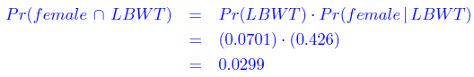

- From the same source of data, it is also estimated that the probability of infants being female is 0.48. What is the estimate of the probability that a normal birthweight infant is female?

By the total probability rule:

We know:
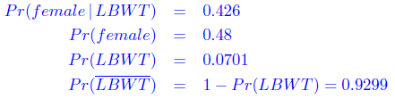

So plugging into Pr(female):

With a little algebra, we get:
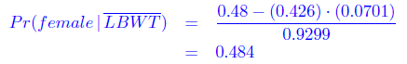

2. Use the information given in Rosner 8th edition, pp. 66-67 (7th edition, pp. 61-62; 6th edition - pp. 69-70) concerning Genetics. Answer questions:
8th edition: 3.32-3.35, 3.37-3.42
7th edition: 3.30-3.33, 3.35-3.40 These were provided
6th edition: 3.31-3.34, 3.36-3.41
Assume that offspring inherit the disease independently of each other. Show your work (include probability tree diagrams, if useful). Assume the family has one boy and one girl.
For Genetics:

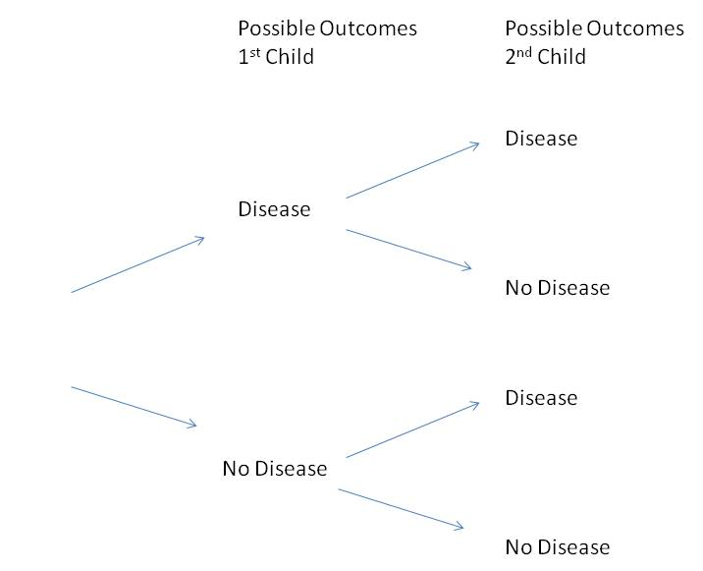

Dominant mode of inheritance

8th 3.32/ 7th 3.30/ 6th 3.31
The probability that in a family with two children, both siblings are affected if the two events are independent is:
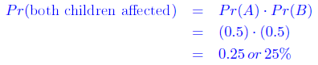

8th 3.33/ 7th 3.31/ 6th 3.32
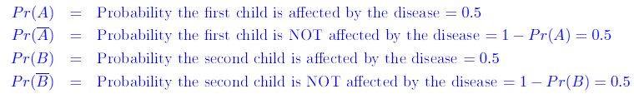

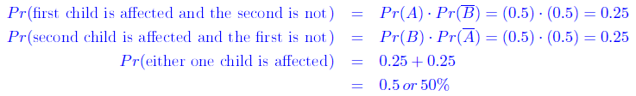

8th 3.34/ 7th 3.32/ 6th 3.33
The probability that in a family with two children, neither sibling is affected if the two events are independent is:
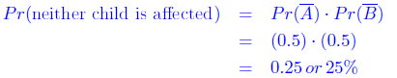

8th 3.35/ 7th 3.33/ 6th 3.34
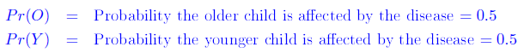
Because the two events are independent, the probability that the younger child is affected given that the older child is affected is:
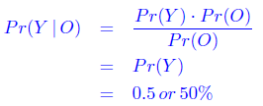

Autosomal recessive mode of inheritance

8th 3.37/ 7th 3.35/ 6th 3.36
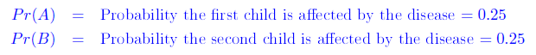
The probability that in a family with two children, both siblings are affected if the two events are independent is:
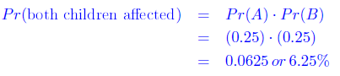

8th 3.38/ 7th 3.36/ 6th 3.37
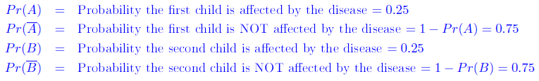

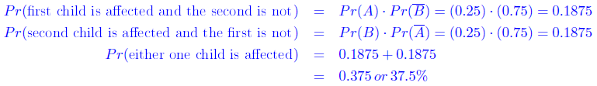

8th 3.39/ 7th 3.37/ 6th 3.38
The probability that in a family with two children, neither sibling is affected if the two events are independent is:
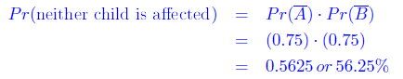

Sex-linked mode of inheritance
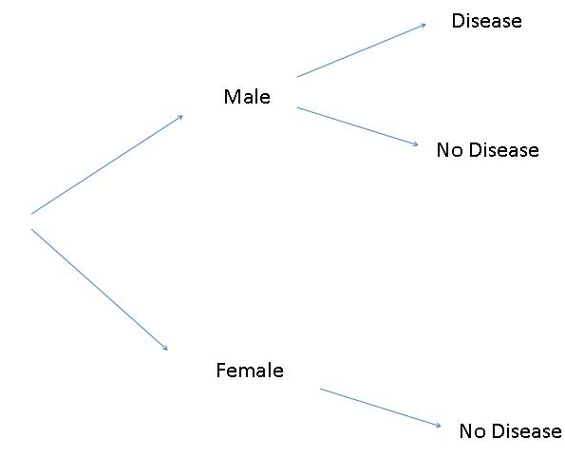

8th 3.40/ 7th 3.38/ 6th 3.39
The probability that in a family with two children, both siblings are affected if the two events are independent is:
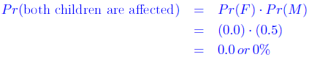

8th 3.41/ 7th 3.39/ 6th 3.40
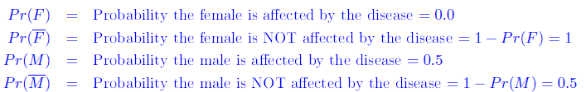

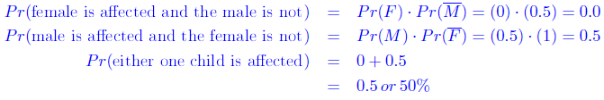

8th 3.42/ 7th 3.40/ 6th 3.41
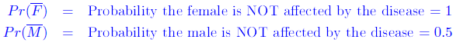
The probability that in a family with two children, neither sibling is affected if the two events are independent is:
